**BPM-comparisons and remarks for the FETS project…**

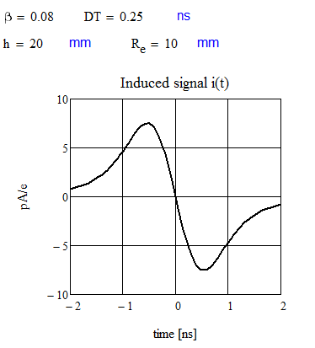

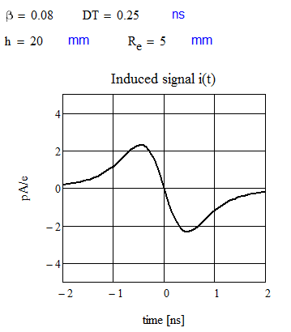

Means the signal goes nearly proportional to the button size, which is as expected.

The Bunch length for the .25 ns bunch is (in mm):



We increase the size of the button and due to a length of nearly 80 mm in beam direction the signal will be deformed:

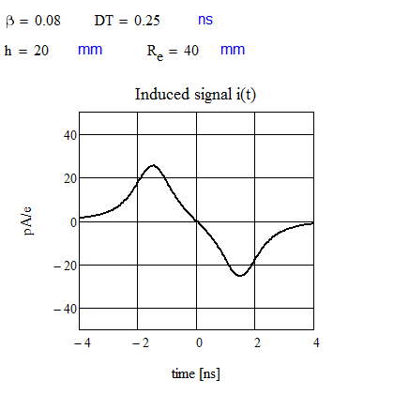

Because the period of the bunches with RF=324 MHZ is only 3.086 ns bunches will overlap.

Therefore the length of the electrode should not too large in comparison to the bunch length.

We calculate the signal for a ring shaped pick up in strip-line technique (50 Ohms) and divide it in four segments.

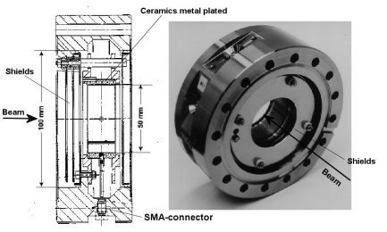

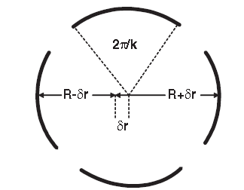

We take each segment as 1/6 of the circumference

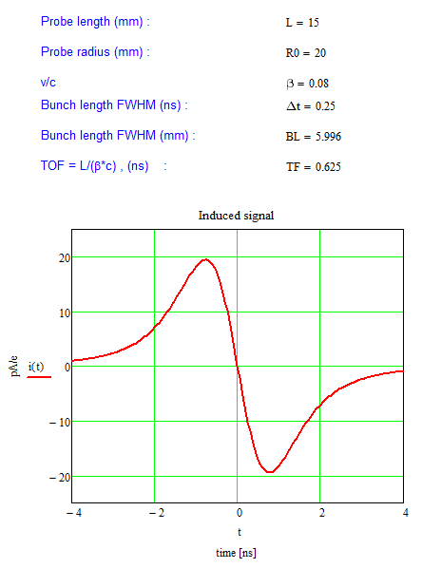

Here L = 15 mm inn beam direction and TOF is the time of flight through the pick up. The signal holds for 1/6 of the signal from the whole ring

We gain roughly a factor of 4 against the button size with R=5 mm. This signal strength can be compared with the signal for a button with

R=40 mm, but the signal is not deformed. The length of the signal

is clearly determined by the advanced bunch field (due to the small ß-value)

Theory leads to a half width of R0/(ßc) for a single particle (corresponds to bunch length=0) and L=0, which gives 0.83 ns in our case. The next picture confirms this, if one takes also the finite length L into consideration. We estimate:

$HWFM\sim \sqrt[2]{.83+{TF}^{2}}\sim 1ns$ The next diagram shows the calculated time between maximum and minimum of the signal as shown above in relation of the bunch width.

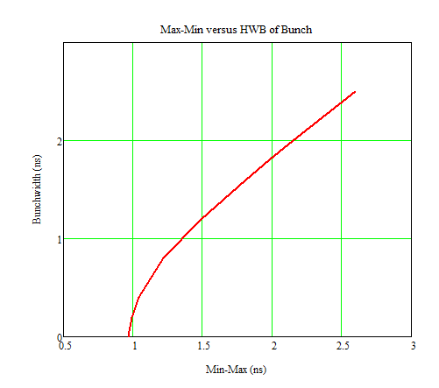

The diagram confirms, there is no direct measurement of the bunch width possible up to a bunch length of about 1 ns. The estimation of measured bunch length for a single particle is confirmed by the diagram

Conclusion: Measurement of bunch shape with capacitive pick ups or strip line monitors for a beam with ß=.08 is nearly not possible, if the bunch length very short (<2 ns). The next picture show some examples:

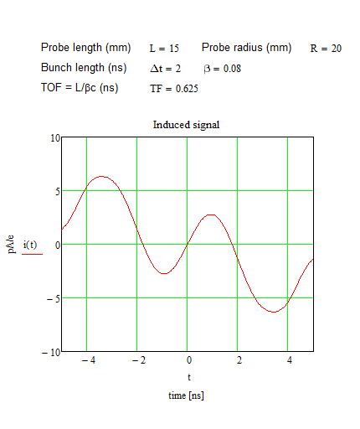

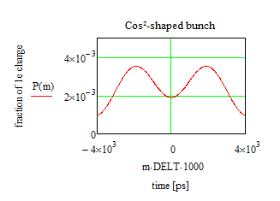

Now consider the bandwidth, which is required to observe the signal from the pick up:

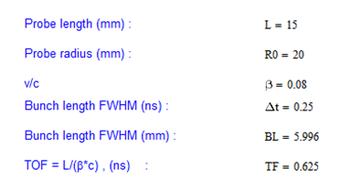

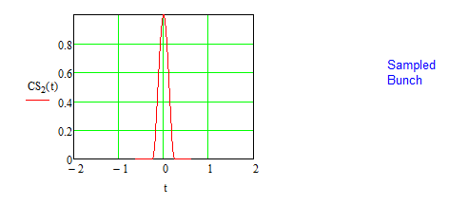

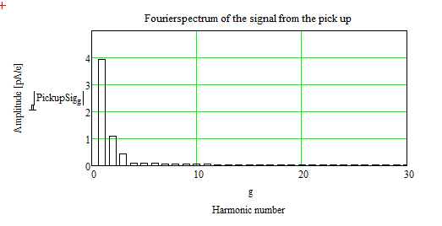

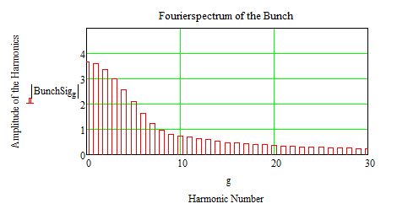

Corresponds to about 1 GHz

Remark: Bunch shape measurement is very limited, as discussed above. It's not possible to optimize the sensitivity to position measurement in combination with the limited bunch shape measurement.

Keeping in mind that the collected charge on the electrodes is proportional to the area it is possible to increase the segment in beam direction up to a limit, which is given by the bunch length including the advanced signal. In case of high impedance signal processing the sensitivity for position measurement can be much higher as for low impedance signal processing, which is necessary to observe the bunch shape, too.

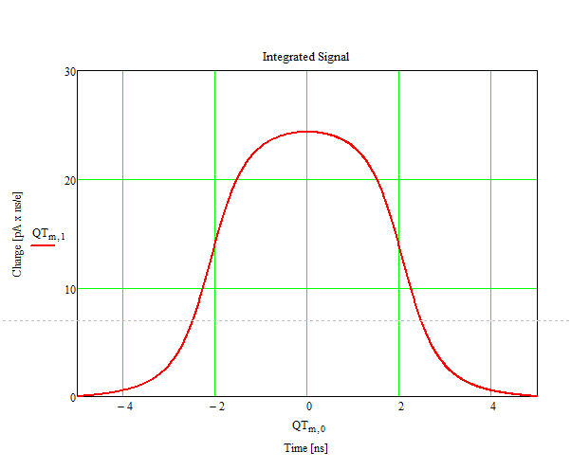

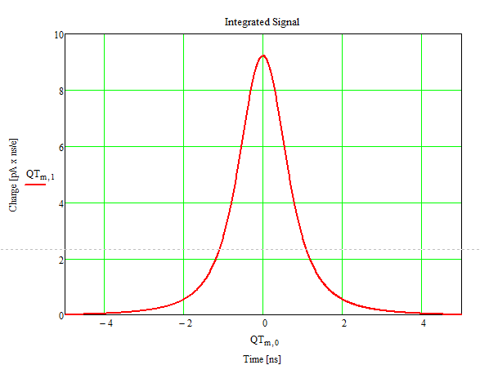

The left diagram holds for L=15 mm and the right one for L=100 mm

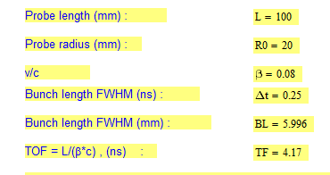

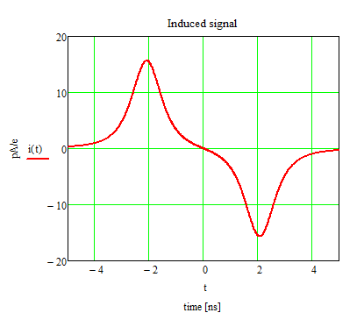

**Two more examples of electrode systems:**

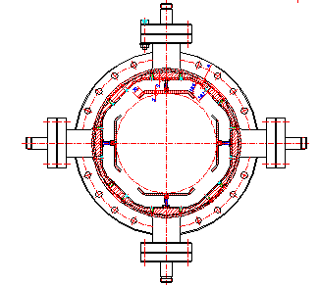

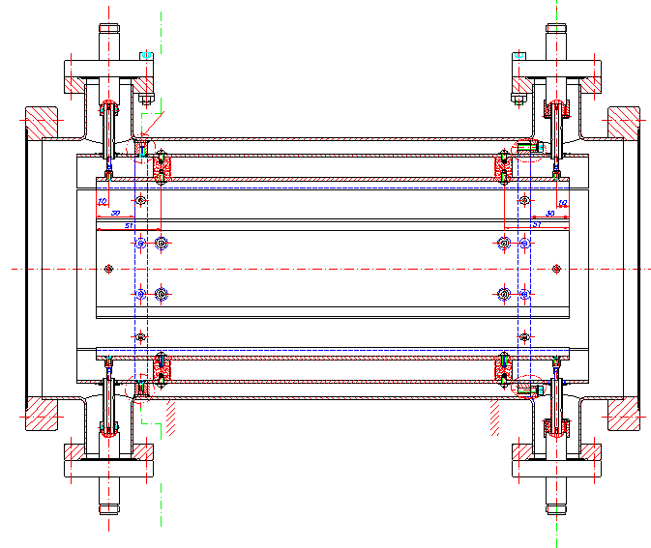

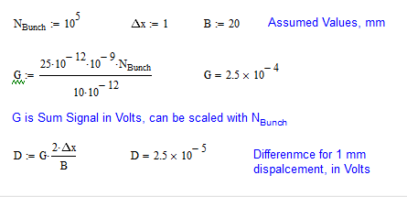

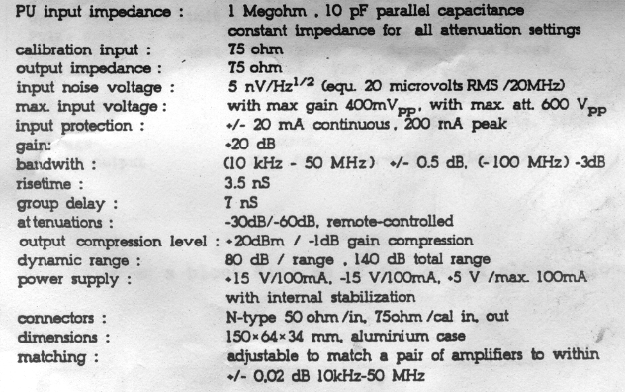

Assuming a capacity of 10 pF reasonable for the electrodes we get the difference signal to:

The **linear cut electrode system**. It has the advantage to be linear over an extended beam. The sensitivity S has to be multiplied with the sum signal G to get the difference signal.

Therefore if we assume a plate length (beam direction) of 100 mm and 20 mm in width (B) we get a charge of about 25 pA x ns as shown in the diagram above.

Typical specification of a BPM-electronics.

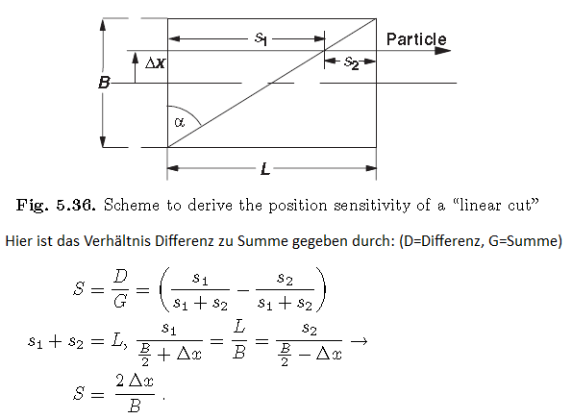

Above, **universal strip line monitor**, provided for measurement of protons and electrons. Four of the connectors can be removed, if only one kind of particles has to be measured. Mounting the connectors in the middle of the strips an electrostatic pick up results as discussed above.

Final conclusion: For position measurement we would recommend the linear cut system.

To measure bunch length and/or bunch shape within discussed limits (advanced field, retarded field due to low ß-value) we recommend a ring shaped monitor.

But we think there are a lot of arguments presented in this short paper for an own decision.

P. Strehl for NTG, 3/26/2013