MEBT design.... graphs...

from WIKI version 29.11.2013

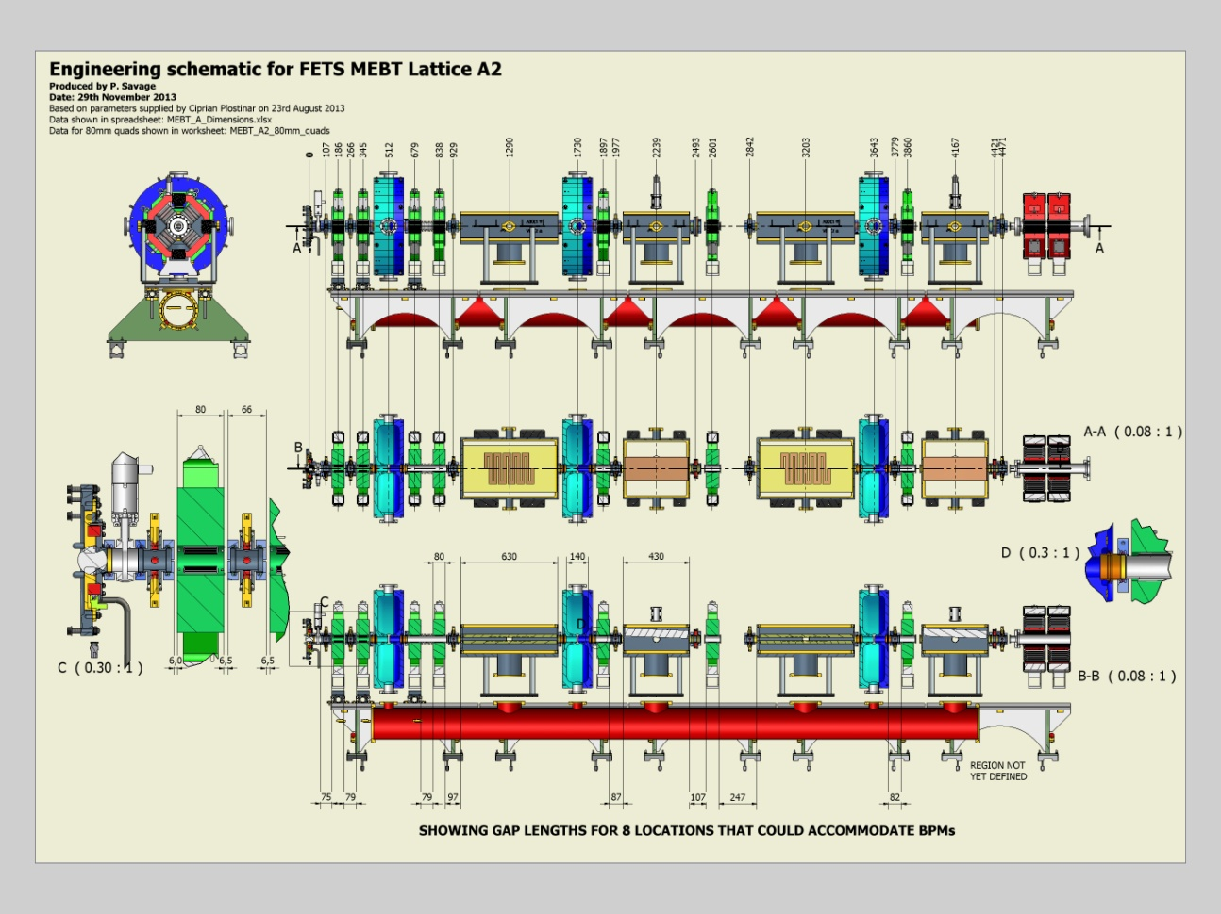

from Ajits talk version April 2014

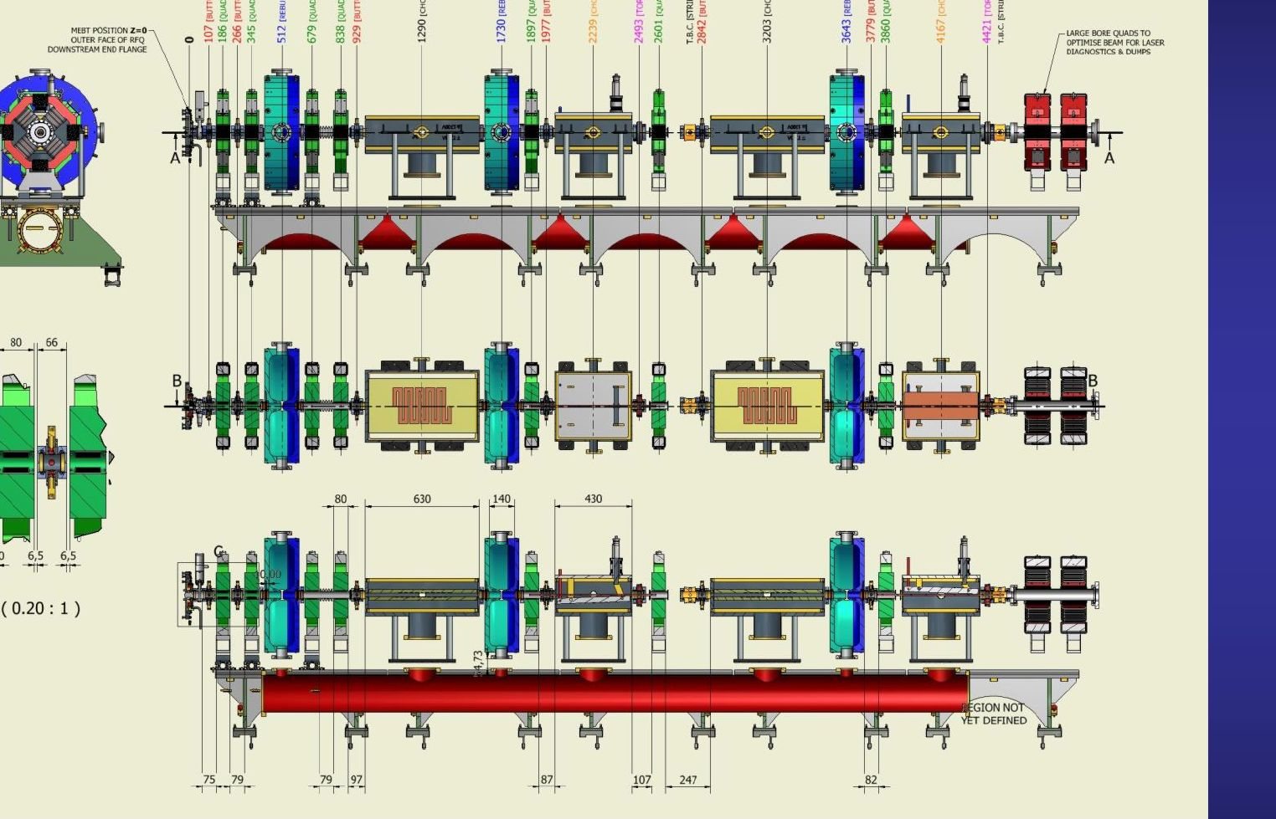

both are practically identical. = baseline

Comparison with GPT input file

Quadrupole position

Q1z= 0.186 ok

Q2z= 0.345 ok

Q3z= 0.679 ok

Q4z=0.838 ok

Q5z=1.897 ok

Q6z=2.601 ok

Q7z=3.860 ok

==========

Q8z=4.474 diag

Q9z=4.633 diag

cavity position

Cav1z=0.512; ok

Cav2z=1.730; ok

Cav3z=3.643; ok

chopper position and length

CH1z=1.290; ok LCH1=0.6045; external 0.63

CH2z=3.203; ok LCH2=0.6045; external 0.63

beam dump position

BD1z=2.239; ok

BD2z=4.167; ok

=============================

=> GPTinput file seem to be consistent with MEBT eng drawings.

defintion of beam dump plates

scatterplate("wcs", 0, -0.015, BD1z, 1,0,0 ,0,0.0211,0.9998,0.1,0.38) scatter="remove";

center position in z as in drawing. x on beam axis and y -15 mm from beam axis

1.2 degree angle to z axis, 100 mm wide, 380 mm long

scatterplate("wcs", 0, 0.015, BD2z, 1,0,0 ,0,0.0211,-0.9998,0.1,0.38) scatter="remove";

center position in z as in drawing. x on beam axis and y +15 mm from beam axis

-1.2 degree angle to z axis, 100 mm wide, 380 mm long

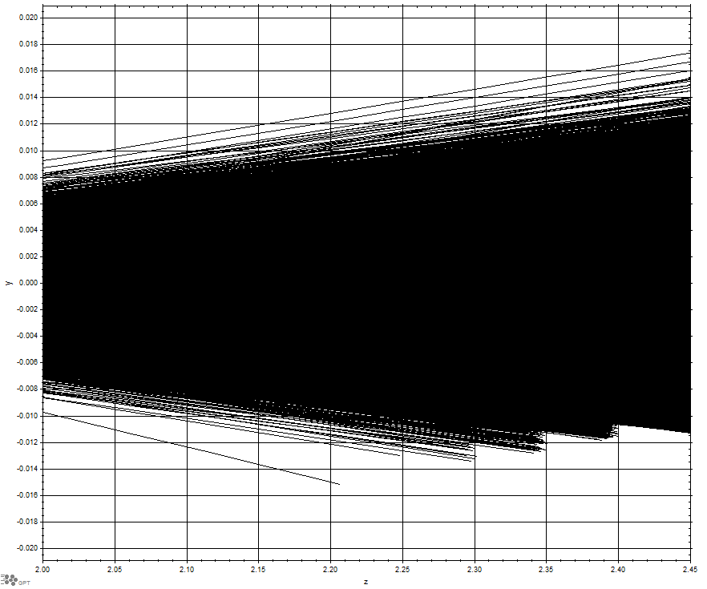dump1 no chopper

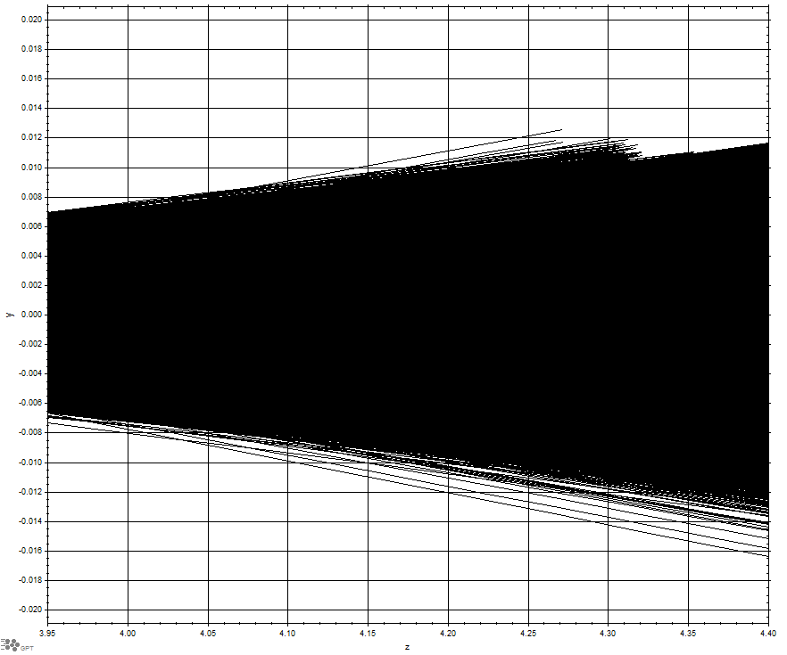dump2 no chopper

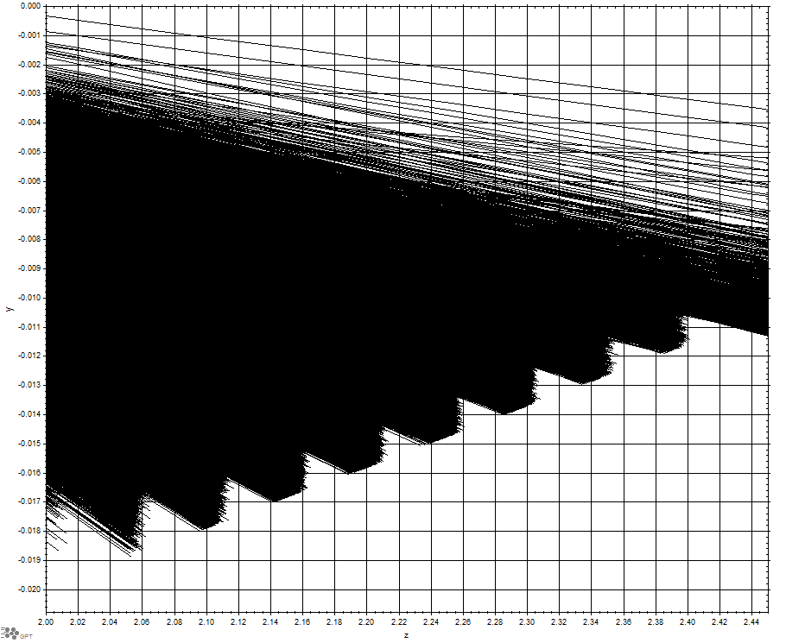dump1 chopper 1 on

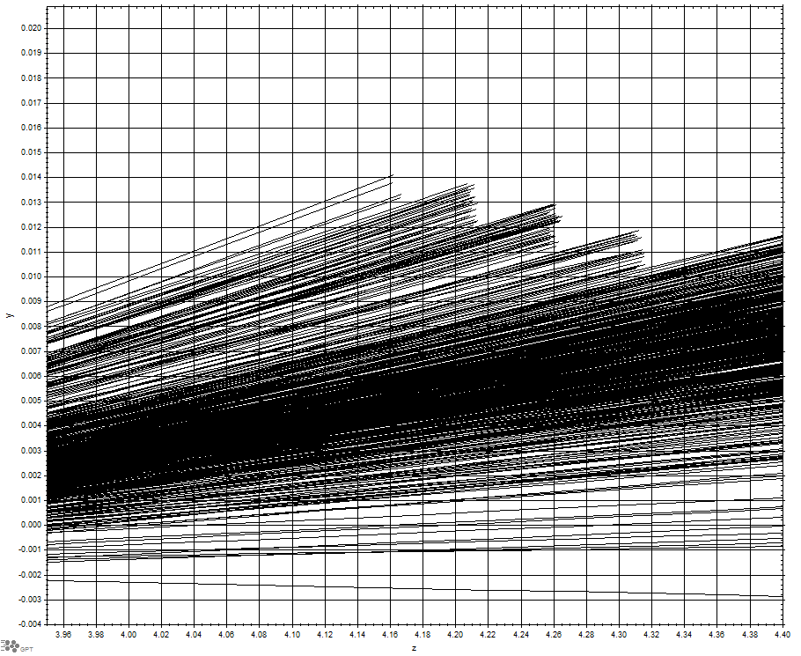 dump2 chopper 1 on

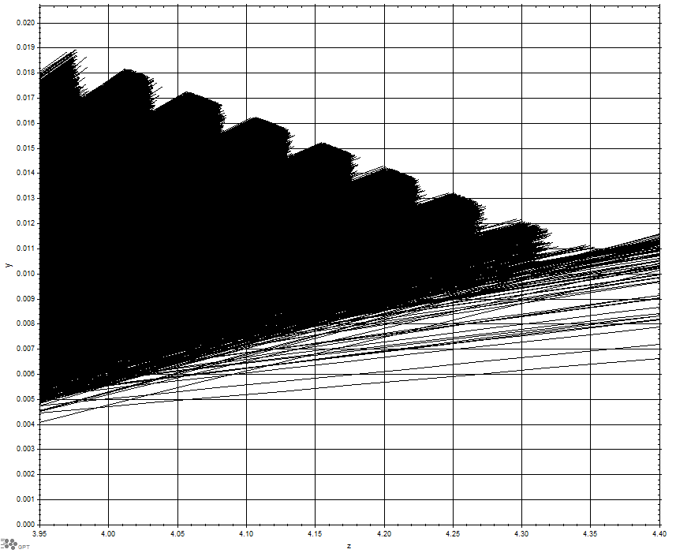

dump 2 chopper 2 on

losspatterns

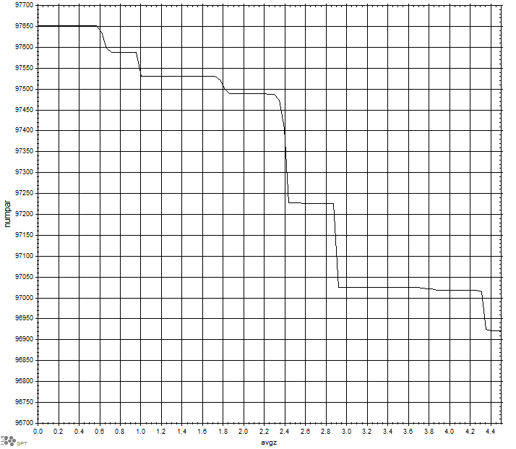

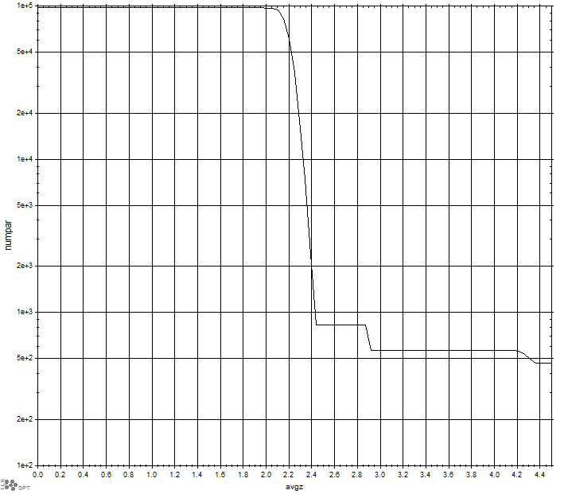

chopper 1

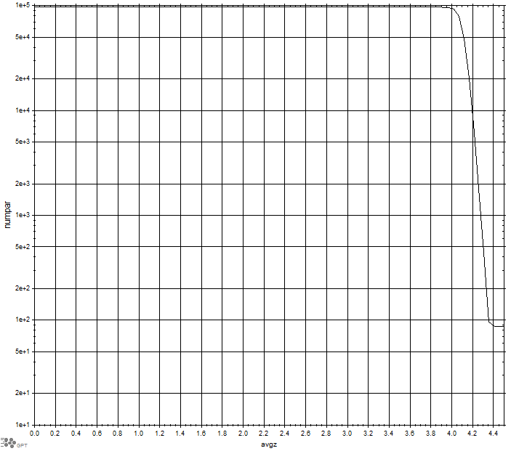

chopper 2

no chopper







chopper1







chopper 2





